T. Gallagher*, S.W. Leemans*, A. Dvornikov, K. Perinbam, J. Fong, C. Kim, J. Kapcia, M. Kagawa, A. Grosvirt-Dramen, A. Hochbaum, M. Digman, E. Gratton, A. Siryaporn, K. Whiteson

* T.G. and S.W.L. contributed equally

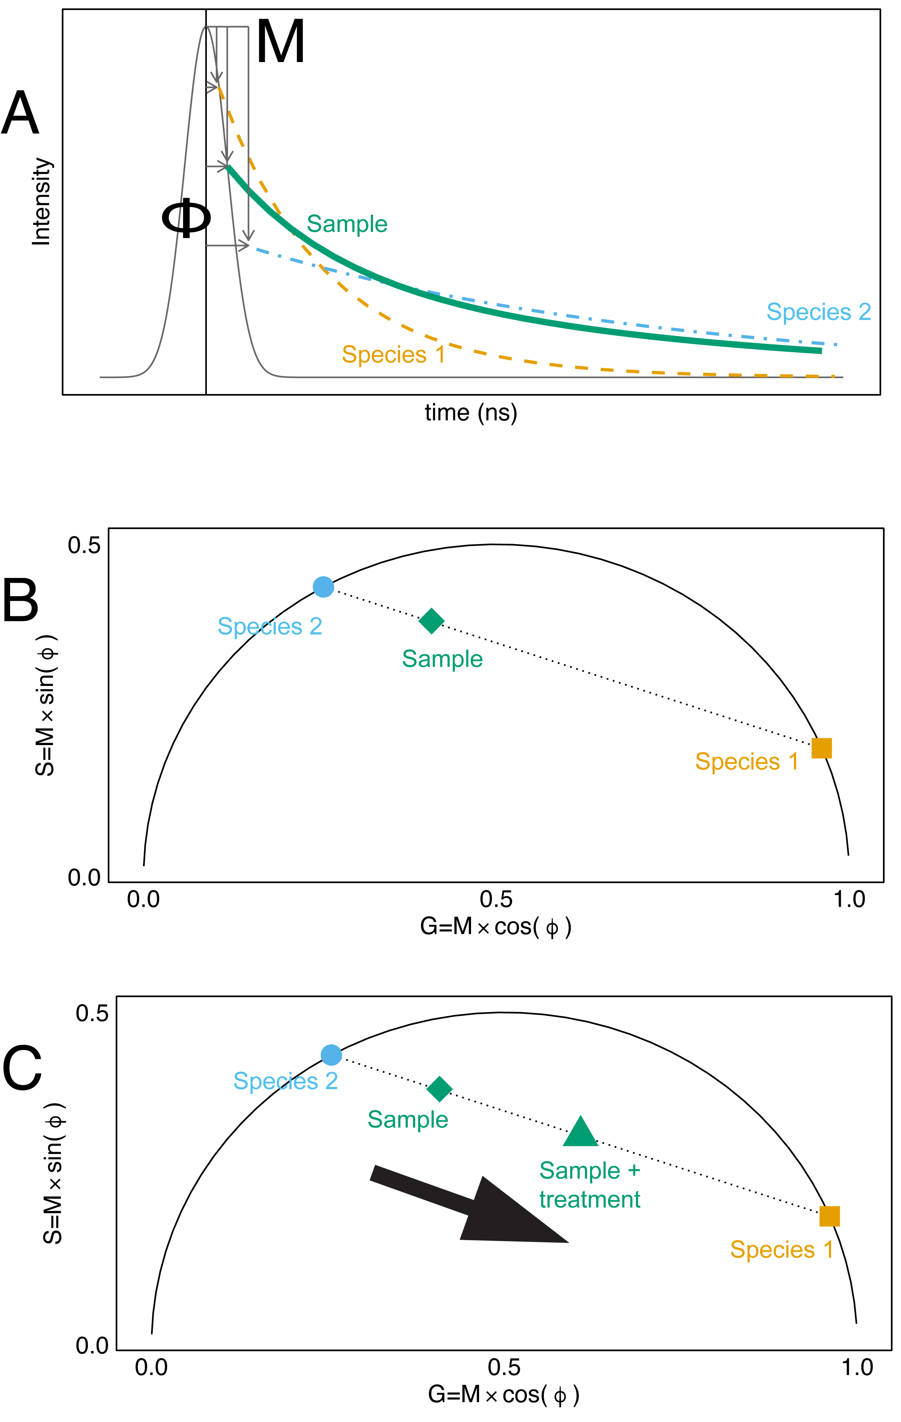

**Figure 1:** A simplified representation of the transformation of fluorescence exponential decays into the fluorescence lifetime phasor. **(A)** A Fourier transform is used to calculate the modulation (M) and phase shift (φ) relative to the laser pulse excitation source. M and φ are represented graphically for two pure fluorophores (orange dash line, blue dash-dot line) and a sample containing a mix of the two species (green solid line) (1). **(B)** The phasor G and S coordinates are the cosine and sine components of the Fourier transforms. Species closer to the origin of the phasor have long lifetimes, whereas species on the right corner of the phasor have short lifetimes (1). **(C)** Shifts in the phasor coordinates of samples can be indicative of changes in the relative abundance of fluorescence species. For example, in a sample containing two fluorescent species, shifts in the phasor position are associated with shifts in the abundance of the two fluorescent species (1, 2).

**Figure 2: Fluorescent spectra and lifetime phasor of some of the fluorescent metabolites produced by *P. aeruginosa***(two-photon excitation = 740 nm).

(**A**) Florescence emission spectra normalized by max peak intensity of fluorophores which emit in the 400-500 nm window. (**B**) Fluorescence lifetime phasor of fluorescent solutions, collected with a Schott BG-39 filter and NADH-targeted optical bandpass emission filter (400-500 nm). Points represent the phasor G and S coordinates from a fluorescence lifetime image, colored by the number of pixels. The large shapes represent the mean G and S values for each fluorescent solution. The mean G and S values for MDH NADH and OLS were determined from previously-reported fluorescence lifetimes (3, 4). MDH = Malate Dehydrogenase, OHPhz = 1-hydroxyphenazine, OLS = Oxidized Lipid Signal, PVD = pyoverdine, PYO = pyocyanin.

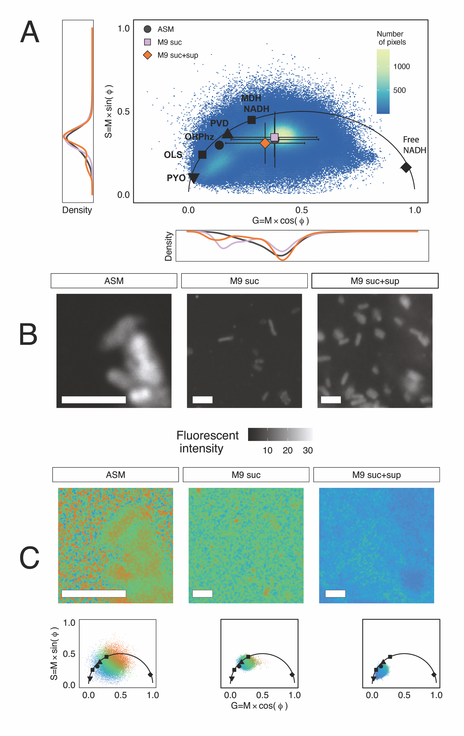

**Figure 5: Fluorescence lifetime shifts from the cross-feeding experiment.** (**A**) Fluorescence lifetime phasor of *P. aeruginosa* PaFLR01 grown in three media types at hypoxic conditions for 72h. Scatter plot points are G and S coordinates of all the fluorescence lifetime images of PaFLR01 grown in hypoxic ASM (14 images), M9 suc (8 images), or M9 suc + sup (7 images), colored by number of pixels. For reference, mean G and S values of fluorescent solutions are displayed on the universal circle as black shapes. Mean G and S values for each media condition are represented by colored shapes with error bars (ASM = grey circle, M9 suc = lavender square, M9 suc + sup = orange diamond). The two-dimensional G and S distributions were significantly different for each pairwise comparison (ASM vs. M9 suc, ASM vs. M9 suc+sup, M9 suc vs. M9 suc+sup; Fasano-Francheschini Test, p-value < 2.2e-16). The one-dimensional distributions of G and S are on the side-panels and colored by media condition. M9 suc + sup G and S distributions are shifted to the left of the M9 suc and ASM distributions (Wilcoxon rank sum test, p-value < 2.2e-16; **Table 1**). (**B**) Examples of fluorescent intensity images from the cross-feeding experiment. Scale bar = 3 µm. (**C**) The fluorescence lifetime image (top) and phasor coordinates of pixels (bottom) from three example samples, colored by lifetime. Blue is indicative of a longer lifetime near the origin of the phasor (0,0). Scale bar = 3 µm. MDH = Malate Dehydrogenase, OHPhz = 1-hydroxyphenazine, OLS = Oxidized Lipid Signal, PVD = pyoverdine, PYO = pyocyanin, ASM = artificial sputum medium, suc = succinate, sup = supernatant from *Rothia mucilaginosa*.

* Figure 1: Schematic of phasor representation of lifetime (code: schematic.rmd)
* Figure 2 (code: spectral_flim_phasor.Rmd, Phasor_fig2.py, Spectral_fig2.py) :
  + A. Two-photon emission spectra of fluorophores that are captured by DIVER acquisition settings.
  + B. 1st harmonics FLIM phasor of fluorophores, acquired by DIVER.
* Figure 3: Lifetime shifts with depth in WT biofilm, not phzko biofilm.
  + A. All phasors, colored by pixel counts? (4 columns, gridded by condition)
  + B. All phasors, colored by depth with G and S distribution colored and linetype by depth (11 colors)

Figure 4: FLIM phasor

* + B. WT Pa biofilm and phz ko fluorescent intensity example images @ surface of biofilm (4 columns)
  + C. WT Pa biofilm and phz ko fluorescent lifetime example images throughout biofilm (4 columns) color mapped lifetime with inset phasor
* Figure 5: Shifts in fluorescence lifetime in liquid Pa cultures from fermentation products.
  + A. Phasor of ALL images (3 cols), One phasor – mean with distributions on x and y axis (1 col)
  + B. P1 single cell fluorescent intensity image – hypoxic M9 succinate (72h), hypoxic M9 succinate + sup (72h), ASM (3 cols)
  + C. Color mapped lifetime of example images (3 cols)

Supplemental Figures:

* Figure S1: Spectra of fluorophores not captured by DIVER FLIM : PCA, PCN, CPX, FAD.
* Figure S2: Raw spectra plots of (A) PYO and (B) OHPhz (pyo brighter).
* Figure S3: TCEP reduction of PYO – gradient and pH experiments.
  + A. Spectra of PYO + TCEP gradients
  + B. 1st harmonics phasor of PYO TCEP gradients
* Figure S4: Electrochemical reduction of pyocyanin
  + A. color pictures
  + B. phasor
* Figure S5: Pa phasor compared to other bacteria – Entero, Rothia, Strep, Steno
* Figure S6: PYO correlates with FLIM (???)
* Figure S7:
  + Aerobic x-feeding
  + Other additional timepoints x-feeding
* Figure S8:
  + Biofilm data

Supplemental Tables:

* Table S1 (microscope, objective, excitation, filter used)
  + laser powers for diver and lsm 880
* Table S2: dyes

Fasano-Francheschini Test

data: f_m9s and f_m9sup

D-stat = 0.14135, p-value < 2.2e-16

sample estimates:

dff,1 dff,2

0.1413527 0.1413527

Fasano-Francheschini Test

data: f_asm and f_m9s

D-stat = 0.15639, p-value < 2.2e-16

sample estimates:

dff,1 dff,2

0.1566879 0.1560859

Fasano-Francheschini Test

data: f_asm and f_m9sup

D-stat = 0.1942, p-value < 2.2e-16

sample estimates:

dff,1 dff,2

0.1942036 0.1941875

>

> # M9 suc + sup is shifted to left of M9 suc

> # one-sided alternative "greater" is that x is shifted to the right of y

>

> wilcox.test( y = unlist(subset(all_binned, media_sup == 'M9 suc')[,c('binned_g1')]),

+ x = unlist(subset(all_binned, media_sup == 'M9 suc+sup')[,c('binned_g1')]),

+ alternative = c('less'))

Wilcoxon rank sum test with continuity correction

data: unlist(subset(all_binned, media_sup == "M9 suc+sup")[, c("binned_g1")]) and unlist(subset(all_binned, media_sup == "M9 suc")[, c("binned_g1")])

W = 68342846, p-value < 2.2e-16

alternative hypothesis: true location shift is less than 0

>

> wilcox.test( y = unlist(subset(all_binned, media_sup == 'M9 suc')[,c('binned_s1')]),

+ x = unlist(subset(all_binned, media_sup == 'M9 suc+sup')[,c('binned_s1')]),

+ alternative = c('less'))

Wilcoxon rank sum test with continuity correction

data: unlist(subset(all_binned, media_sup == "M9 suc+sup")[, c("binned_s1")]) and unlist(subset(all_binned, media_sup == "M9 suc")[, c("binned_s1")])

W = 65616238, p-value < 2.2e-16

alternative hypothesis: true location shift is less than 0

>

> # ASM vs M9 s

> #ASM is shifted to left of M9 s

> wilcox.test( y = unlist(subset(all_binned, media_sup == 'M9 suc')[,c('binned_g1')]),

+ x = unlist(subset(all_binned, media_sup == 'ASM')[,c('binned_g1')]),

+ alternative = c('less'))

Wilcoxon rank sum test with continuity correction

data: unlist(subset(all_binned, media_sup == "ASM")[, c("binned_g1")]) and unlist(subset(all_binned, media_sup == "M9 suc")[, c("binned_g1")])

W = 133340179, p-value = 0.8281

alternative hypothesis: true location shift is less than 0

>

> wilcox.test( y = unlist(subset(all_binned, media_sup == 'M9 suc')[,c('binned_s1')]),

+ x = unlist(subset(all_binned, media_sup == 'ASM')[,c('binned_s1')]),

+ alternative = c('less'))

Wilcoxon rank sum test with continuity correction

data: unlist(subset(all_binned, media_sup == "ASM")[, c("binned_s1")]) and unlist(subset(all_binned, media_sup == "M9 suc")[, c("binned_s1")])

W = 124779822, p-value < 2.2e-16

alternative hypothesis: true location shift is less than 0

>

> #M9s is shifted to left of ASM

> wilcox.test( x = unlist(subset(all_binned, media_sup == 'M9 suc')[,c('binned_g1')]),

+ y = unlist(subset(all_binned, media_sup == 'ASM')[,c('binned_g1')]),

+ alternative = c('less'))

Wilcoxon rank sum test with continuity correction

data: unlist(subset(all_binned, media_sup == "M9 suc")[, c("binned_g1")]) and unlist(subset(all_binned, media_sup == "ASM")[, c("binned_g1")])

W = 131718516, p-value = 0.1719

alternative hypothesis: true location shift is less than 0

>

> wilcox.test( x = unlist(subset(all_binned, media_sup == 'M9 suc')[,c('binned_s1')]),

+ y = unlist(subset(all_binned, media_sup == 'ASM')[,c('binned_s1')]),

+ alternative = c('less'))

Wilcoxon rank sum test with continuity correction

data: unlist(subset(all_binned, media_sup == "M9 suc")[, c("binned_s1")]) and unlist(subset(all_binned, media_sup == "ASM")[, c("binned_s1")])

W = 140278873, p-value = 1

alternative hypothesis: true location shift is less than 0

>

>

> # ASM vs M9 sup

> # M9 sup is shifted to left of ASM

> wilcox.test( x = unlist(subset(all_binned, media_sup == 'M9 suc+sup')[,c('binned_g1')]),

+ y = unlist(subset(all_binned, media_sup == 'ASM')[,c('binned_g1')]),

+ alternative = c('less'))

Wilcoxon rank sum test with continuity correction

data: unlist(subset(all_binned, media_sup == "M9 suc+sup")[, c("binned_g1")]) and unlist(subset(all_binned, media_sup == "ASM")[, c("binned_g1")])

W = 101252195, p-value < 2.2e-16

alternative hypothesis: true location shift is less than 0

>

> wilcox.test( x = unlist(subset(all_binned, media_sup == 'M9 suc+sup')[,c('binned_s1')]),

+ y = unlist(subset(all_binned, media_sup == 'ASM')[,c('binned_s1')]),

+ alternative = c('less'))

Wilcoxon rank sum test with continuity correction

data: unlist(subset(all_binned, media_sup == "M9 suc+sup")[, c("binned_s1")]) and unlist(subset(all_binned, media_sup == "ASM")[, c("binned_s1")])

W = 107347720, p-value < 2.2e-16

alternative hypothesis: true location shift is less than 0

<https://www.teknova.com/trace-metals-mixture-1000x>

**Formulation**

* 50mM Ferric chloride
* 20mM Calcium chloride
* 10mM Manganese chloride
* 10mM Zinc Sulfate
* 2mM Cobalt chloride
* 2mM Cupric chloride
* 2mM Nickel chloride
* 2mM Sodium molybdate
* 2mM Sodium selenite
* 2mM Boric acid

Pyoverdine + ferritin

Ferritin serves as a critical component of iron homeostasis, as shown in [Figure 2](https://www.ncbi.nlm.nih.gov/pmc/articles/PMC2717717/figure/F2/). Its’ primary role is in iron sequestration in which it functions as a ferroxidase, converting Fe(II) to Fe(III) as iron is internalized and sequestered in the ferritin mineral core.

At physiological pH, ferrous ion quenched the fluorescence of all three pyoverdines much faster than ferric ion did. Also, increased absorbance at 460 nm was observed to be much faster for Fe2+-pyoverdine than for Fe3+-pyoverdine

<https://www.tandfonline.com/doi/abs/10.1080/10934520500423501>

<https://www.nature.com/articles/s41598-019-56913-x>

color_map_1<-c(

"Enzyme-bound NADH"="#E9D8A6",

"MDH NADH"= "#001219",

"Free NADH"= "#001219",

"PVD"="#CA6702",

"PYO"="#0A9396",

"PYO (Reduced)" = "#0A9396",

"FAD" = "#EE9B00" ,

"CPX" = "#9B2226")

shape_maps<-c(

"Enzyme-bound NADH"=22,

"MDH NADH"=22,

"Free NADH"=23,

"PVD"=24,

"PYO"=25 ,

"PYO (Reduced)" = 25 ,

"FAD" = 21 ,

"CPX" = 22 )

The emission was filtered with a Schott BG-39 filter and NADH-targeted optical bandpass filter (400-500 nm)

**TEXT:**

**METHODS:**

**Fluorescent Solutions.**

Pyocyanin (>98%) was ordered from Sigma-Aldrich (P0046). 10 mM stocks were prepared by dissolving in 20% ethanol. 1-Hydroxyphenazine (>95%) was ordered from Fisher Scientific (H0289100MG) and dissolved in methanol to create a 10 mM stock. Stocks were stored at -20˚C.

NADH

FAD

CPX

PCA

PCN

**Chemical reduction of 1-hydroxyphenazine and pyocyanin.**

For hyperspectral and fluorescence lifetime imaging, 1X MOPS buffer, TCEP (pH7), and 10 mM stocks of 1-hydroxyphenazine and pyocyanin were transferred to an anaerobic chamber at least three days before imaging. On the day of imaging, pyocyanin and 1-hydroxyphenazine diluted with MOPS and TCEP to generate 1 mM fluorophore / 1 mM TCEP solutions.

For the pyocyanin gradient experiments, five hundred micromolar stocks of pyocyanin were diluted in 1X MOPS buffer with concentration gradients of TCEP (pH 7) ranging from 0.1 mM to 125 mM.

**Electrochemical reduction of pyocyanin.**

Following the protocol developed by Wang and Newman (166), a fresh stock of 821 μM of pyocyanin was prepared in ammonium acetate 0.1M KCl MOPS buffered solution in and electrochemically reduced The electrochemical cell consisted of a glassy carbon working electrode, platinum wire counter electrode, and Ag/AgCl2 reference electrode. The voltage was set to -0.345V, and the reaction proceeded in an anaerobic chamber overnight until the current reached zero.

**Bacterial media.**

Artificial sputum and M9 minimal media with 40 mM succinate were used to grow P. aeruginosa biofilms. The recipes for both media types were modified from Gao et al. (100) to include 0.28% final agar concentration. To visualize biofilm colony growth over time, the agar was prepared in large petri dishes (150x15 mm).

**Bacterial strains and growth.**

P. aeruginosa PA14 and the phenazine knockout phzA1-G1/A2-G2 were obtained from Dianne Newman’s lab at California Institute of Technology (ref). For biofilm imaging, the bacteria were grown overnight on Todd-Hewitt agar, and individual colonies were inoculated into the center of the artificial sputum or M9 succinate soft agar plates. The biofilm colonies were grown aerobically at 37 ̊C for 3 days.

**Spectral Imaging.**

**Fluorescence lifetime imaging.**

**RESULTS:**

**Spectral and FLIM phasor characterization of *P. aeruginosa* fluorophores.**

The two-photon fluorescence emission spectra of *P. aeruginosa* fluorophores were characterized (NADH, enzyme-bound NADH, FAD, pyoverdine, pyocyanin, 1-hydroxy-phenazine, copoprophoryin) (**Fig. S3.1**) and agreed overall with previously published spectra (5). Different reduction methods of pyocyanin changed the fluorescence spectra and lifetime phasor results. The resulting pyocyanin population likely consisted of a mix of the radical and reduced form, but the FLIM phasor analysis suggests our FLIM setup primarily acquired the reduced form (**Fig. S3.2**).

Four of the seven species were captured by the FLIM DIVER acquisition parameters, which included an emission filter targeted towards NADH (400-500 nm): NADH, enzyme-bound NADH, and reduced pyocyanin, and apo-pyoverdine (**Fig. S3.1**). The FLIM and HIM phasor components for the pure fluorescent species were determined, and pyocyanin had a distinct FLIM and HIM phasor signature (**Fig. 3.2**). To compare the detected fluorescent species across both methods, the HIM spectral window was truncated to 410-500 nm to exclude measurements of species not captured with our FLIM acquisition settings (**Fig. S1**).

References

1. Digman MA, Caiolfa VR, Zamai M, Gratton E. 2008. The Phasor Approach to Fluorescence Lifetime Imaging Analysis. Biophysical Journal 94:L14–L16.

2. Stringari C, Edwards RA, Pate KT, Waterman ML, Donovan PJ, Gratton E. 2012. Metabolic trajectory of cellular differentiation in small intestine by Phasor Fluorescence Lifetime Microscopy of NADH. Scientific Reports 2:568.

3. Jameson DM, Thomas V, Zhou D. 1989. Time-resolved fluorescence studies on NADH bound to mitochondrial malate dehydrogenase. Biochimica et Biophysica Acta (BBA) - Protein Structure and Molecular Enzymology 994:187–190.

4. Datta R, Alfonso-García A, Cinco R, Gratton E. 2015. Fluorescence lifetime imaging of endogenous biomarker of oxidative stress. Scientific reports 5:1–10.

5. Sullivan NL, Tzeranis DS, Wang Y, So PTC, Newman D. 2011. Quantifying the Dynamics of Bacterial Secondary Metabolites by Spectral Multiphoton Microscopy. ACS Chem Biol 6:893–899.